How to Prepare and Design your Poster Presentation
Adapted from http://www2.napier.ac.uk/gus/writing_presenting/academic_posters.html

Poster Deadlines: Draft Due April 15 Final Draft: April 29

Size Guidelines: (hxw) 36” x 48”
A tri-folding poster board will be provided to you. You will have space for 12 8.5x11 panels
Sample templates will be available on the aar.pausd website

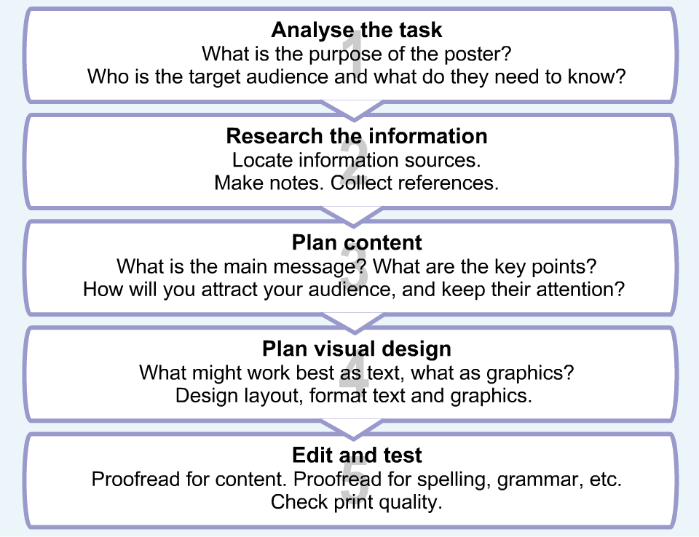
Posters are an effective way of communicating concisely, visually and attractively, and can be a powerful way of getting information across. Academic posters summarize information or research concisely and attractively, to help publicize it and generate discussion.
- Academic posters can reach a wide audience as they may be displayed for several hours or days, at national or international conferences.
- They may also be published online as part of conference proceedings, becoming part of a permanent record of research activity.
- An effective poster can make a strong impact, so it's worth developing your poster planning skills.
- A good poster should be:
• well researched
• effectively organized
• self-explanatory
• visually attractive

Planning your Content
It takes skill to summarize a complex topic without losing meaning or connections.
Since a poster must communicate concisely, you need to spend some time identifying your key points.
- Decide what you need to communicate, and how.
- What is your main message? What does your viewer need to know?
- Identify the key points, always keeping your topic or task in mind.
- Note the graphics you might need, such as photos, diagrams, graphs or charts.
- Once you've decided on the main content, make a rough draft of the information you need.
- Decide on the main title.
- Academic posters need to show evidence of reading and research, so you must always include references.

Structure / Format – depends on your content and what you’re trying to communicate
Reporting on research  If you are reporting on a piece of research, your structure may be similar to a research report  - Introduction  - Methods / Materials  - Results  - Discussion  - Conclusion  - References | Reporting on a solution to a problem  If you are illustrating how a particular problem was solved, or how a challenge was addressed, the structure may be:  - Title  - Background  - Definition of problem  - Possible solutions  - Rationale for choice of one solution  - Implementation  - Evaluation
Planning your Design
Once you've identified your main content and structure, you need to identify the graphics and formatting which will communicate your message best.
- How will you organize your content visually?
- How might you use color and type to enhance visual impact?
- It's usually best to design from the outside in, thinking about the general purpose before the details.
Remember: It's important to be very clear about the purpose of your poster.
Keep returning to this as you plan your design.

Visual Impact  Posters are designed to convey a message quickly and efficiently. What should your viewer see and understand first?  - Think what will communicate your key points most clearly.  - Find a focal point that will help draw your viewers in. This might be a key flowchart or diagram, or simply a clear main title.  - Make sure important graphics or information stand out clearly in your design.  Remember, you may not need graphics if words are more powerful.  Tip: In an academic poster, the priority is to be clear, concise and professional. | Layout  What visual arrangement will suit your content best, and how will you lead the reader through it?  - Try to provide a clear entry point for readers, and a logical visual flow.  - Group related information.  - Use numbering or arrows if linked content should be read in a particular order.  - Avoid either oversimplifying (too little useful information) or overcomplicating (too much information).  - Use 'negative' space and margins to give your content room to breathe.

Fonts
- A poster should be legible from about one meter, and attract interest from about five meters.
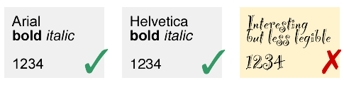
- Aim for a word count of about 300 to 800 words. 300 words leaves plenty of room for graphics, while 800 words would be more text heavy.
- For clarity, use a Sans-serif font like Arial or Helvetica. Make sure there is good contrast between text and background.
- To be legible at a distance, the main title should be around 70-100 pts, subheadings around 40 pts, body text around 24 pts.
- Be consistent in formatting headings and subheadings. This helps structure your information visually.

Graphics
An academic poster should be both professional and concise, so a general rule is only to include graphics that really support your content.
- Use diagrams, graphs or flowcharts to help explain complex information visually.
- Try not to use too many different or strongly contrasting colors. A limited color palette can be very effective.
- Avoid using unnecessary and distracting background textures or decoration.
- To print effectively, images should be high resolution (150-300 dpi)
- If your topic has a central statement, graphic or diagram, make this prominent in your design. Don't hide it in a corner!
- Every graphic should have a purpose.

Final Tips….
- Allow plenty of time to prepare and produce your poster – it’s going to take longer than you think!
- Make sure you know the time, date, and location of the session.
- Think about what you will say, anticipate likely questions and practice your responses.

